**Page Explanations**

**Index Page**

The index page is a hub page for the website. When accessed the default page is the index page. Here the user is given a brief description of what the website does and is given links on what they should do next in the website i.e. Login or Register.

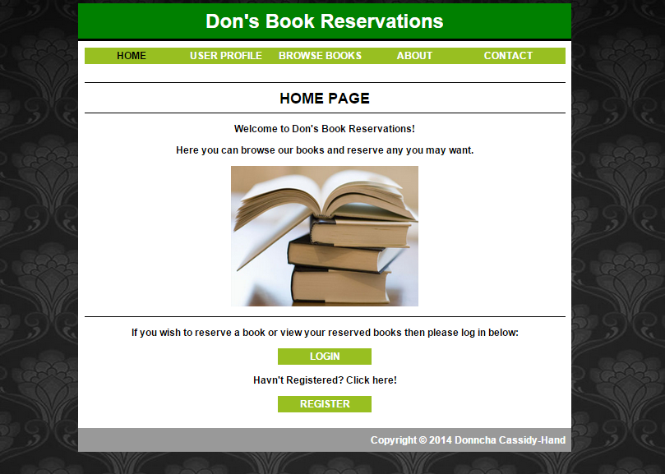

**Login Page**

On the login page the user can login if they already have an account by providing their username and password where prompted. If either the password or username is wrong when the user clicks “login-in”, then the user will be directed back to the login page. If they are both correct then the user will be directed to the userpage.

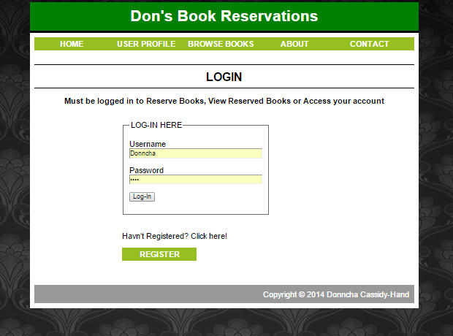

**Registration Page**

On the registration page will allow the user to sign up so that they can log in. In order for the user to successfully register they need to fill in all the prompted details and follow the set rules e.g. the username must be unique, the password must be no more than 6 characters, the mobile number must be no more than 10 character long etc.

When the user has filled in all the details they can click “Submit” to then submit their registration.

If any of the details are not entered in correctly the user will be presented with an error explaining what they failed to enter correctly.

**Error checking in place:**

* Check if Username or Email is unqiue
* Chcek if Password is no longer than 6 characters
* Check if Mobile Number is no longer than 10 integers
* Check if all text boxes are filled in
* Check if password and the confirmation password are matching

If the criteria above isn’t fullfilled then an appropriate error will be displayed.

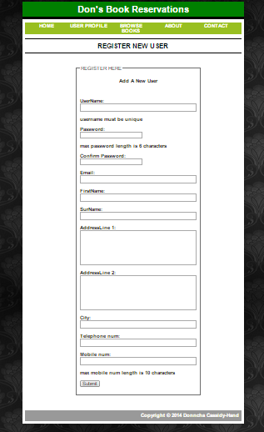

**Userpage**

The user page displays the logged in users information. This page works as a hub for the user to edit their profile, logout or view their reservations.

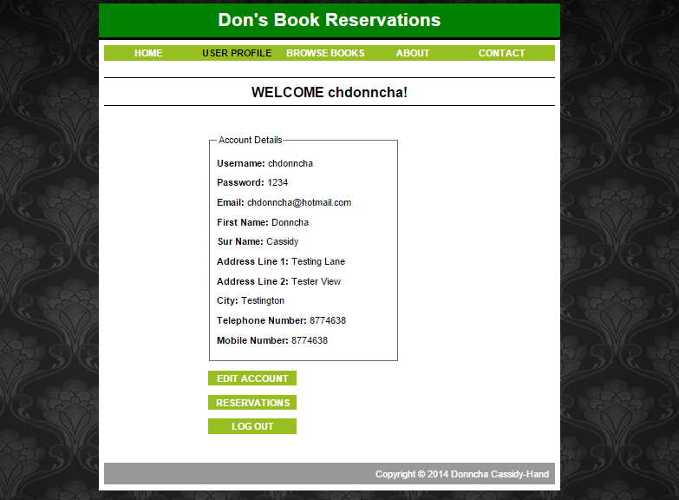

**Browse books (logged in)**

This is the browse for book page as displayed if the user is logged in. When the user is logged in the reserve function will be available allowing the user to check the reserve box and then clicking “reserve selected books” to finalise their decision.

The user will be displayed all the books upon entry to the page to allow them to browse all the books. The user can either search by title, author or category. The user can search by key terms in the Title or Author search boxes e.g. by typing “comp” in the Title search will bring up all books with the term “comp” in their booktitle.

**Error Checking:**

* Check if user is logged in if not redirect to searchnl.php

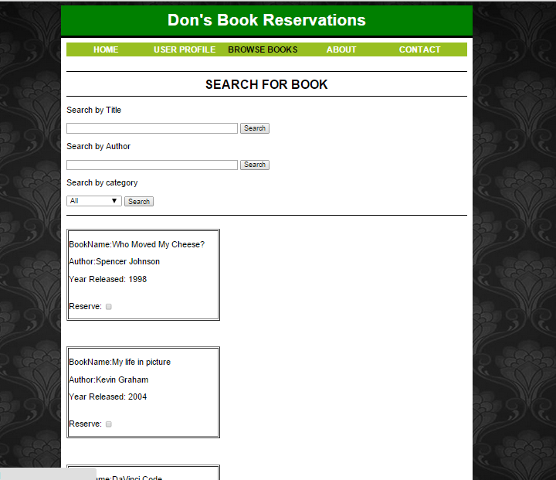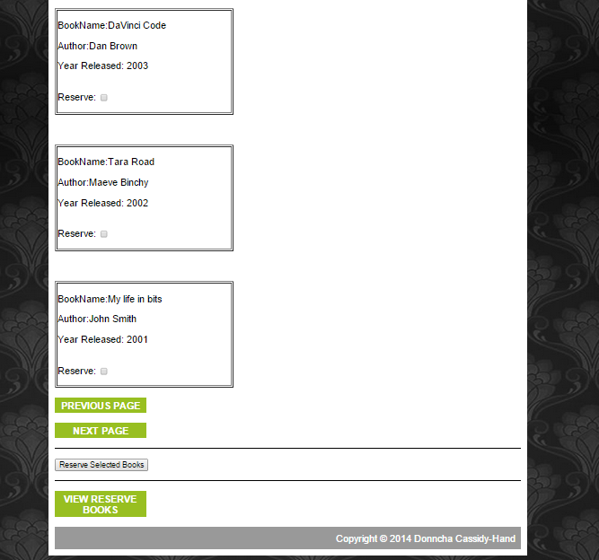

**Browse books (not logged in)**

The browse books page will more or less function the same as it does when the user is logged in except that the “reserve” checkbox is removed and the reserve book submit button.

The users will be directed to this page if they attempt to use search.php and the user is not logged in.

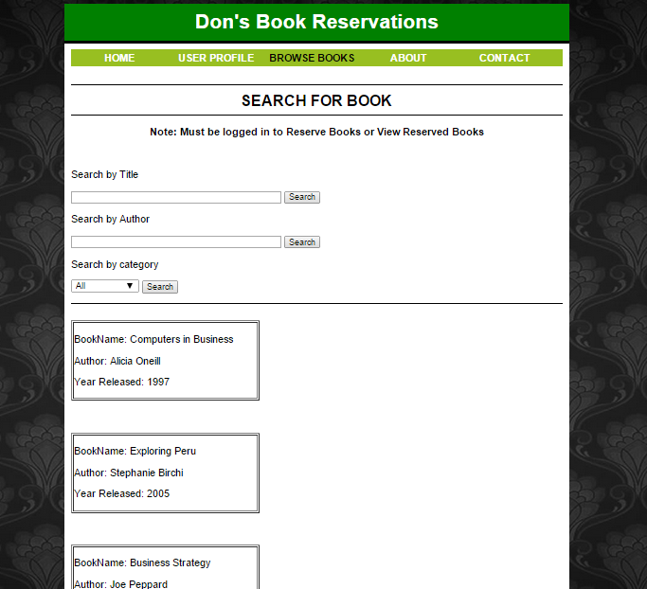 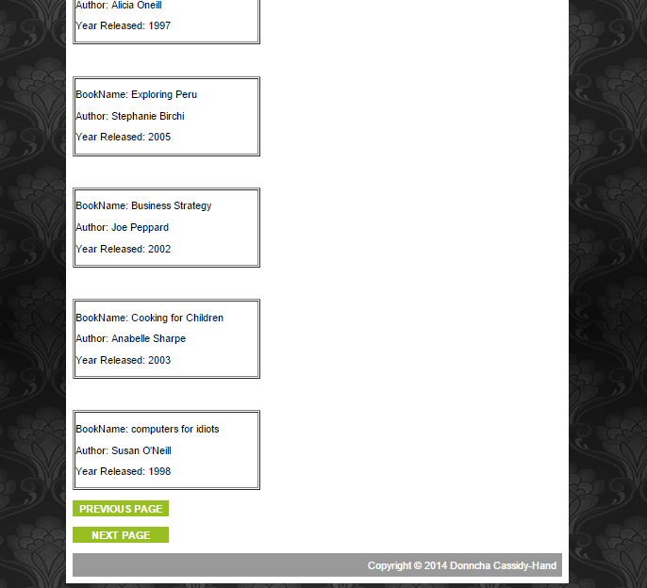

**View Reservations Page**

On this page the user can view all their reservations and choose to whether or not to un-reserve the book. The user can proceed to un-reserve the book then by clicking “Un-reserve Selected Books” and will then proceed to un-reserve the selected books.

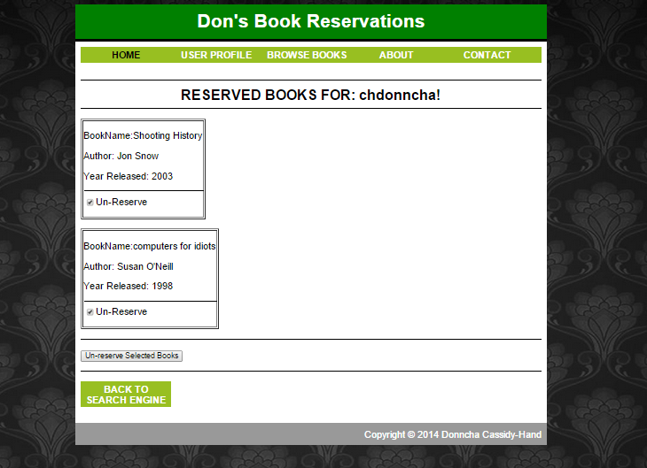

If the user has no books reserved they will be displayed the following when they enter the view reservations page.

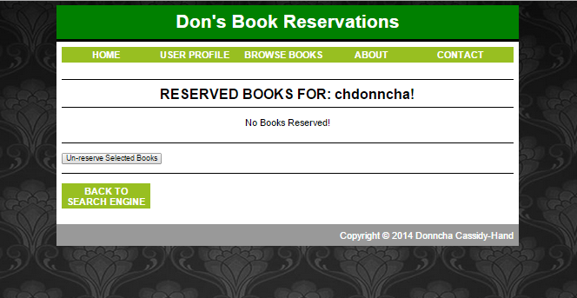

**About Page**

The about page is a html page that displays a summary of what the website is about and the goals of the website.



**Contact Page**

The contact page is an html page that displays a list of ways that a user can get in contact with the administrators of the website for support regarding the website.

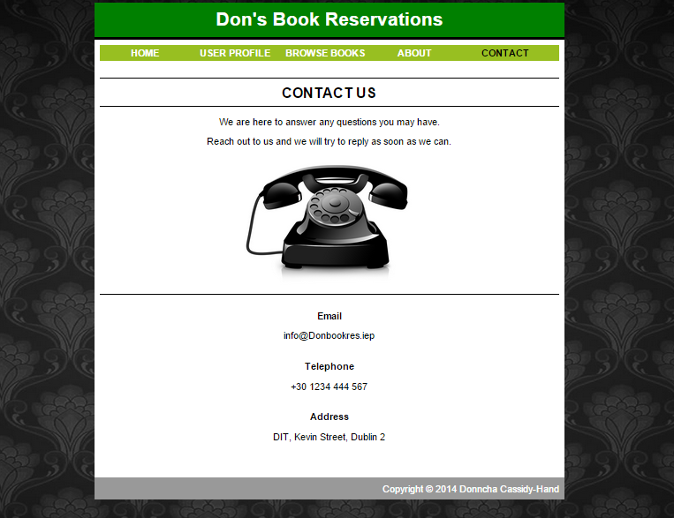

**Source Code**

**Style.css**

body {

background-image: url("http://www.hdpaperwall.com/wp-content/uploads/2013/10/website-backgrounds-hd-arena.jpg");

background-color: #EEE;

font-family: Helvetica, Arial, sans-serif;

}

a {

text-declaration: none;

color: red;

}

ul {

list-style-type: none;

margin: 0;

padding: 0;

overflow: hidden;

background-color:#98bf21;

text-align:center;

}

table{

min-width: 300px;

}

li {

float: left;

display:inline-block;

}

a:link, a:visited {

display: block;

width: 145px;

font-weight: bold;

color: #FFFFFF;

background-color: #98bf21;

text-align: center;

padding: 4px;

text-decoration: none;

text-transform: uppercase;

}

a:hover, a:active {

background-color: #7A991A;

}

textarea {

resize: none;

}

h1, h2, h3{

text-align: center;

margin: 0;

}

#container {

background-color: white;

width: 800px;

margin-left: auto;

margin-right: auto;

}

hr {

border-style: solid;

border-bottom: black;

}

#header {

background-color: #008000;

color: white;

text-align: center;

padding: 10px;

<hr>

border-style: solid;

border-bottom: solid black;

</hr>

}

#content {

padding: 10px;

background-color: white;

}

#nav {

width: 780px;

float: left;

background-color: #66CCFF;

}

#nav ul {

list-style-type: none;

padding: 0;

}

#nav .selected {

font-weight: bold;

color: black;

}

#main {

width: 600px;

float: right;

}

#footer {

clear:both;

padding: 10px;

background-color: #999999;

color: white;

text-align: right;

}

**Index.html**

<html>

<head>

<title>Index</title>

<link rel="stylesheet" type="text/css" href="style.css" />

</head>

<body>

<div id="container">

<div id="header">

<h1>Don's Book Reservations</h1>

</div>

<div id="content">

<div id="nav">

<ul>

<!-- Navigation bar -->

<li><a class = "selected" href="index.html" >Home</a></li>

<li><a href="userpage.php" >User Profile</a></li>

<li><a href="search.php" >Browse Books</a></li>

<li><a href="about.html" >About</a></li>

<li><a href="contact.html" >contact</a></li>

</ul>

</div>

<p><h2><br><hr> HOME PAGE </h2><hr><p>

<center><p><b>Welcome to Don's Book Reservations!<b><p> Here you can browse our books and reserve any you may want.<p>

<img src="books.jpg" alt="books" style="width:304px;height:228px"><br><hr>

<p>If you wish to reserve a book or view your reserved books then please log in below:<p>

<a href="login.php">Login</a><p>

<p>Havn't Registered? Click here!<p>

<a href="registration.php">Register</a></p></center>

</div>

<div id="footer">

Copyright &copy; 2014 Donncha Cassidy-Hand

</div>

</form>

</body>

</html>

**Login.php**

<html>

<head>

<title> Login</title>

<link rel="stylesheet" type="text/css" href="style.css" />

</head>

<body>

<div id="container">

<div id="header">

<h1>Don's Book Reservations</h1>

</div>

<div id="content">

<div id="nav">

<ul>

<!-- Navigation bar -->

<li><a href="index.html" >Home</a></li>

<li><a href="userpage.php" >User Profile</a></li>

<li><a href="search.php" >Browse Books</a></li>

<li><a href="about.php" >About</a></li>

<li><a href="contact.php" >contact</a></li>

</ul>

</div>

<p><h2><br><hr> LOGIN </h2><hr><p>

<p><b><center>Must be logged in to Reserve Books, View Reserved Books or Access your account</center></b><p>

<div id="main">

<p>

<body id="body-color">

<div id="Sign-In">

<fieldset style="width:30%">

<legend>LOG-IN HERE</legend>

<form method="POST" action="loginConnection.php"><p>

Username

<br><input type="text" name="user" size="40"><br><p>

Password

<br><input type="password" name="pass" size="40"><br>

<p><input id="button" type="submit"

name="submit" value="Log-In"></p>

</div>

<br><p>Havn't Registered? Click here! <p><a href="registration.php">Register</a><p><br>

</div>

<div id="footer">

Copyright &copy; 2014 Donncha Cassidy-Hand

</div>

</form>

</body>

</html>

**LoginConnection.php**

<?php

define('DB_HOST', 'localhost');

define('DB_NAME', 'book');

define('DB_USER','root');

define('DB_PASSWORD','');

// initalise variables to connect to database

$con=mysql_connect('localhost', 'root', '') or die("Failed to connect to MySQL: " . mysql_error());

$db=mysql_select_db('book',$con) or die("Failed to connect to MySQL: " . mysql_error());

//starting the session for user profile page

function SignIn() { session_start();

//checking the 'user' name which is from Sign-In.html, is it empty or have some text

if(!empty($_POST['user']))

{

$query = mysql_query("SELECT * FROM Users where Username = '$_POST[user]' AND Password = '$_POST[pass]'") or die(mysql_error());

$User = mysql_fetch_array($query);

if(!empty($User['Username']) AND !empty($User['Password'])) {

$_SESSION['Username'] = $User['Username']; // create and name global session variable

header("Location: http://localhost/WebD/Assignment%201/Bookstore/userpage.php");

}

else{

header("Location: http://localhost/WebD/Assignment%201/Bookstore/login.php?err=1");

}

}

}

if(isset($_POST['submit']))

{ SignIn(); }

?>

**Logout.php**

<?php

session_start();

$_SESSION = array();

session_destroy();

header("Location: http://localhost/WebD/Assignment%201/Bookstore/index.html");

?>

**Registration.php**

<html>

<head>

<title> BookStore</title>

<link rel="stylesheet" type="text/css" href="style.css" />

</head>

<body>

<div id="container">

<div id="header">

<h1>Don's Book Reservations</h1>

</div>

<div id="content">

<div id="nav">

<ul>

<!-- Navigation bar -->

<li><a href="index.html" >Home</a></li>

<li><a href="userpage.php" >User Profile</a></li>

<li><a href="search.php" >Browse Books</a></li>

<li><a href="about.html" >About</a></li>

<li><a href="contact.html" >contact</a></li>

</ul>

</div>

<p><h2><br><hr> REGISTER NEW USER </h2><hr><br><p>

<div id="main">

<body id="body-color">

<div id="Sign-In">

<fieldset style="width:60%">

<legend>REGISTER HERE</legend> <?php

require_once "db.php";

if ( isset($_POST['Username']) && isset($_POST['Password'])

&& isset($_POST['Email']) && isset($_POST['FirstName'])

&& isset($_POST['SurName']) && isset($_POST['AddressLine1'])

&& isset($_POST['AddressLine2']) && isset($_POST['City'])

&& isset($_POST['Telephone']) && isset($_POST['Mobile'])) {

$u = trim($_POST['Username']);

$p = trim($_POST['Password']);

$e = trim($_POST['Email']);

$f = trim($_POST['FirstName']);

$s = trim($_POST['SurName']);

$a = trim($_POST['AddressLine1']);

$b = trim($_POST['AddressLine2']);

$c = trim($_POST['City']);

$t = trim($_POST['Telephone']);

$m = trim($_POST['Mobile']);

// check if username or email is already in use

$q = mysql_query("SELECT * FROM users WHERE Username = '". $u ."' OR email = '". $e ."'");

if (mysql_num_rows($q) > 0)

{

echo '<p><b><center>error: Username or email already in use</center></b>';

}

else

{

// integer mobile not allowed to be longer than 10

if (strlen($m) >= 10){

echo "<p><b><center>error: mobile number longer than 10</center></b>";

}

else

{

// string password not allowed to be longer than 6

if (strlen($p) >= 6){

echo "<p><b><center>error: password longer than 6</center></b>";

}

else

{

// check if passwords from Password and ConfPassword match

if ($_POST['Password'] == $_POST['ConfPassword']) {

// check if all text boxes are filled in

if($u != null and $p != null and $e != null and $f != null and $s != null and $a != null and

$b != null and $c != null and $t != null and $m != null)

{

$sql = "INSERT INTO users (UserName, Password, Email, FirstName, SurName, AddressLine1, AddressLine2,

City, Telephone, Mobile )

VALUES ('$u', '$p', '$e', '$f', '$s', '$a', '$b', '$c', '$t', '$m')";

echo "<p><b><center>Success</center></b>";

mysql_query($sql);

}

else

{

echo "<p><b><center>All fields havn't been entered in!</center></b>";

} // end error check all boxes filled in

} // end check if all fields are filled in

else

{

echo "<p><b><center>Passwords do not match</center></b>";

} // end error check password matching

} // end error check password no longer than 6

} // end error check mobile num no longer than 10

} // end error check if username is already in use

} // end of post

?>

<p><b><h3>Add A New User</h3></b></p><br>

<!-- Display text fields -->

<form method="post">

<p><b>UserName:</b><br>

<textarea type="text" name="Username" cols="40" rows="1" ></textarea></p>

username must be unique

<p><b>Password:</b><br>

<input type="password" name="Password" ><p>

max password length is 6 characters

<p><b>Confirm Password:</b><br>

<input type="password" name="ConfPassword" ></p>

<p><b>Email:</b><br>

<textarea type="text" name="Email" cols="40" rows="1"></textarea></p>

<p><b>FirstName:</b><br>

<textarea type="text" name="FirstName" cols="40" rows="1"></textarea></p>

<p><b>SurName:</b><br>

<textarea type="text" name="SurName" cols="40" rows="1"></textarea></p>

<p><b>AddressLine 1:</b><br>

<textarea type="text" name="AddressLine1" cols="40" rows="5"></textarea></p>

<p><b>AddressLine 2:</b><br>

<textarea type="text" name="AddressLine2" cols="40" rows="5"></textarea></p>

<p><b>City:</b><br>

<textarea type="text" name="City" cols="40" rows="1" ></textarea></p>

<p><b>Telephone num:</b><br>

<textarea type="text" name="Telephone" cols="40" rows="1" ></textarea></p>

<p><b>Mobile num:</b><br>

<textarea type="text" name="Mobile" cols="40" rows="1" ></textarea></p>

max mobile num length is 10 characters

<p><input type="submit" value="Submit"/></p>

</form></p>

</div>

<p><br>

</div>

<div id="footer">

Copyright &copy; 2014 Donncha Cassidy-Hand

</div>

</form>

</body>

</html>

**Userpage.php**

<html>

<head>

<title>Userpage</title>

<link rel="stylesheet" type="text/css" href="style.css" />

</head>

<body>

<div id="container">

<div id="header">

<h1>Don's Book Reservations</h1>

</div>

<div id="content">

<div id="nav">

<ul>

<!-- Navigation bar -->

<li><a href="index.html" >Home</a></li>

<li><a class = "selected" href="userpage.php" >User Profile</a></li>

<li><a href="search.php" >Browse Books</a></li>

<li><a href="about.html" >About</a></li>

<li><a href="contact.html" >contact</a></li>

</ul>

</div>

<div id="userdetails">

<p>

<!-- start php here -->

<?php

define('DB_HOST', 'localhost');

define('DB_NAME', 'book');

define('DB_USER','root');

define('DB_PASSWORD','');

$con=mysql_connect('localhost', 'root', '') or die("Failed to connect to MySQL: " . mysql_error());

$db=mysql_select_db('book',$con) or die("Failed to connect to MySQL: " . mysql_error());

session_start();

if(!empty($_SESSION['Username'])) {

echo "<p><h2><br><hr> WELCOME ". $_SESSION['Username'] . "!</h2><hr><p><br> ";

$validUser = mysql_real_escape_string($_SESSION['Username']);

$query = mysql_query("SELECT * FROM Users WHERE Username = '$validUser' ");

// $query = mysql_query("SELECT * FROM Users WHERE = '.$_SESSION['Username'].'" or die(mysql_error());

?> <div id="main"> <?php

$row = mysql_fetch_array($query);

$_SESSION['Username'] = $row['Username'];

?>

<fieldset style="width:50%">

<legend>Account Details</legend>

<p><b>Username:</b>

<?php

echo(htmlentities($row[0]));

echo("</td><td>");

?>

<p><b>Password:</b>

<?php

echo(htmlentities($row[1]));

echo("</td><td>");

?>

<p><b>Email:</b>

<?php

echo(htmlentities($row[2]));

echo("</td><td>\n");

?>

<p><b>First Name:</b>

<?php

echo(htmlentities($row[3]));

echo("</td><td>\n");

?>

<p><b>Sur Name:</b>

<?php

echo(htmlentities($row[4]));

echo("</td><td>\n");

?>

<p><b>Address Line 1:</b>

<?php

echo(htmlentities($row[5]));

echo("</td><td>\n");

?>

<p><b>Address Line 2:</b>

<?php

echo(htmlentities($row[6]));

echo("</td><td>\n");

?>

<p><b>City:</b>

<?php

echo(htmlentities($row[7]));

echo("</td><td>\n");

?>

<p><b>Telephone Number:</b>

<?php

echo(htmlentities($row[8]));

echo("</td><td>\n");

?>

<p><b>Mobile Number:</b>

<?php

echo(htmlentities($row[8]));

echo("</td><td>\n");

}

else

{

// user logged out and is redirected back to login screen

header("Location: http://localhost/WebD/Assignment%201/Bookstore/login.php");

}

?>

</fieldset>

<p><a href="edituser.php">Edit Account</a></p>

<p><a href="viewreserved.php">Reservations</a></p>

<a href="logout.php">Log out</a>

<p><br>

<!-- end php here -->

</div>

</div>

<div id="footer">

Copyright &copy; 2014 Donncha Cassidy-Hand

</div>

</form>

</body>

</html>

**Edituser.php**

<html>

<head>

<title>Edit User</title>

<link rel="stylesheet" type="text/css" href="style.css" />

</head>

<body>

<div id="container">

<div id="header">

<h1>Don's Book Reservations</h1>

</div>

<div id="content">

<div id="nav">

<ul>

<!-- Navigation bar -->

<li><a class = "selected" href="index.html" >Home</a></li>

<li><a href="userpage.php" >User Profile</a></li>

<li><a href="search.php" >Browse Books</a></li>

<li><a href="about.html" >About</a></li>

<li><a href="contact.html" >contact</a></li>

</ul>

</div>

<?php

session_start();

require "db.php";

require "loginConnection.php";

// initalise logged in user variable

$User = $_SESSION['Username'];

if ( isset($_POST['Username']) && isset($_POST['Password'])

&& isset($_POST['Email']) && isset($_POST['FirstName'])

&& isset($_POST['SurName']) && isset($_POST['AddressLine1'])

&& isset($_POST['AddressLine2']) && isset($_POST['City'])

&& isset($_POST['Telephone']) && isset($_POST['Mobile'])) {

// declare variables

$u = mysql_real_escape_string($_POST['Username']);

$p = mysql_real_escape_string($_POST['Password']);

$e = mysql_real_escape_string($_POST['Email']);

$f = mysql_real_escape_string($_POST['FirstName']);

$s = mysql_real_escape_string($_POST['SurName']);

$a = mysql_real_escape_string($_POST['AddressLine1']);

$b = mysql_real_escape_string($_POST['AddressLine2']);

$c = mysql_real_escape_string($_POST['City']);

$t = mysql_real_escape_string($_POST['Telephone']);

$m = mysql_real_escape_string($_POST['Mobile']);

// update given information

$sql = "UPDATE users SET Username='$u', Password='$p', Email='$e', FirstName='$f', SurName='$s', AddressLine1='$a', AddressLine2='$b', City='$c', Telephone='$t', Mobile='$m' WHERE Username='$User'";

echo "<pre>\n$sql\n</pre>\n"; mysql_query($sql);

echo 'Updated - <a href="index.php">Continue...</a>';

return;

}

//$id = mysql_real_escape_string($_GET['id']);

$result = mysql_query("SELECT * FROM users WHERE Username='$User'");

$row = mysql_fetch_row($result);

//$u = $_GET['User'];

$u = htmlentities($row[0]);

$p = htmlentities($row[1]);

$e = htmlentities($row[2]);

$f= htmlentities($row[3]);

$s= htmlentities($row[4]);

$a= htmlentities($row[5]);

$b= htmlentities($row[6]);

$c= htmlentities($row[7]);

$t= htmlentities($row[8]);

$m= htmlentities($row[9]);

//$id = $_GET['id'];

$result = mysql_query("SELECT Username, Password, Email, FirstName, SurName, AddressLine1, AddressLine2, City, Telephone, Mobile FROM users WHERE Username='$User'");

$row = mysql_fetch_row($result);

$u = htmlentities($row[0]);

$p = htmlentities($row[1]);

$e = htmlentities($row[2]);

$f= htmlentities($row[3]);

$s= htmlentities($row[4]);

$a= htmlentities($row[5]);

$b= htmlentities($row[6]);

$c= htmlentities($row[7]);

$t= htmlentities($row[8]);

$m= htmlentities($row[9]);

?>

<p><h2><br><hr> EDIT USER </h2><hr><p><br> <form method="post">

<div id="main">

<!-- print fields to allow editing to user details -->

<fieldset style="width:60%">

<p>Username:<p>

<input type="text" name="Username" value="<?php echo $u; ?>"></p>

<p>Password:<p>

<input type="text" name="Password" value="<?php echo $p; ?>"></p>

<p>Email:<p>

<input type="text" name="Email" value="<?php echo $e; ?>">

<p>FirstName:<p>

<input type="text" name="FirstName" value="<?php echo $f; ?>">

<p>SurName:<p>

<input type="text" name="SurName" value="<?php echo $s; ?>">

<p>AddressLine1:<p>

<input type="text" name="AddressLine1" value="<?php echo $a; ?>">

<p>AddressLine2:<p>

<input type="text" name="AddressLine2" value="<?php echo $b; ?>">

<p>City:<p>

<input type="text" name="City" value="<?php echo $c; ?>">

<p>Telephone:<p>

<input type="text" name="Telephone" value="<?php echo $t; ?>">

<p>Mobile:<p>

<input type="text" name="Mobile" value="<?php echo $m; ?>">

</fieldset>

</p> <input type="hidden" name="id" value="<?php echo $p; ?>">

<p>

<p><input type="submit" value="Update"/>

<br/><p><p>

<a href="index.html">Cancel</a></p> </form>

</div>

</div>

<div id="footer">

Copyright &copy; 2014 Donncha Cassidy-Hand

</div>

</form>

</body>

</html>

**Search.php**

<?php

session_start();

require "db.php";

require "loginConnection.php";

// get logged in user

$User = $_SESSION['Username'] ;

?>

<!DOCTYPE html>

<html lang="en">

<html>

<head>

<title>Search Engine</title>

<link rel="stylesheet" type="text/css" href="style.css" />

</head>

<body>

<div id="container">

<div id="header">

<h1>Don's Book Reservations</h1>

</div>

<div id="content">

<div id="nav">

<ul>

<!-- Navigation bar -->

<li><a href="index.html" >Home</a></li>

<li><a href="userpage.php" >User Profile</a></li>

<li><a class= "selected" href="search.php" >Browse Books</a></li>

<li><a href="about.html" >About</a></li>

<li><a href="contact.html" >contact</a></li>

</ul>

</div>

<section>

<div id="search">

<p><h2><br><hr> SEARCH FOR BOOK </h2><hr><p>

<!-- create the search by title, category and author -->

<form method="POST">

<span>Search by Title</span>

<p>

<input type="text" size ='50' name="title"/>

<button type="submit">Search</button>

</form><p>

<form method="POST">

<span>Search by Author</span><p>

<input type="text" size ='50' name="author"/>

<button type="submit">Search</button>

</form><p>

</div>

<div id="books">

<form method="POST">

<span>Search by category</span><p>

<select name="categories">

<option value="All">All</option>

<?php

$query = "SELECT * FROM categories";

$result = mysql_query($query);

while($row = mysql_fetch_array($result)){

echo "<option value=\"" . $row['CategoryDescription'] . "\">" . $row['CategoryDescription'] . "</option>";

}

?>

</select>

<button type="submit ">Search</button><p><hr>

</form>

<!--display the books in the reservations form -->

<form method="POST">

<?php

if(!empty($_SESSION['Username'])) {

// Check to make sure page is declared and is numeric

// otherwise set page to the first page i.e 0

if(isset($_GET['page']) && is_numeric($_GET['page']) && $_GET['page'] > 0)

$page = $_GET['page'];

else

$page = 0;

$page_query_offset = $page * 5;

$page_url = "http://$_SERVER[HTTP_HOST]".strtok($_SERVER["REQUEST_URI"], "?");

$reset_page = $page_url."?page=" . ($page = 0);

if( $_POST ){

// If there is POST values create a sql query

// search category

if( isset( $_POST['categories'] ) ){

$category = $_POST['categories'];

echo"<h2>" . $category . " Books</h2><hr><p>";

if( $category == 'All' ){

$query = "SELECT * FROM books WHERE reserve='N' LIMIT 5 OFFSET $page_query_offset";

}else{

$query = "SELECT * FROM books b LEFT JOIN categories r ON b.CategoryId = r.CategoryId WHERE r.CategoryDescription='$category' AND b.reserve='N' LIMIT 5 OFFSET $page_query_offset ";

}

} // end search by category.

// search title.

if( isset( $_POST['title'] ) ){

$title = $_POST['title'];

$reset_page;

$query = "SELECT * FROM books WHERE title LIKE '%$title%' AND reserve='N' LIMIT 5 OFFSET $page_query_offset ";

} //end search title.

// search author.

if( isset( $_POST['author'] ) ){

$author = $_POST['author'];

$query = "SELECT * FROM books WHERE author LIKE '%$author%' AND reserve='N' LIMIT 5 OFFSET $page_query_offset";

} // end search author.

// start the query and display the specified books

if( isset( $_POST['categories'] ) || isset( $_POST['title'] ) || isset( $_POST['author'] ) ){

$result = mysql_query($query);

while($row = mysql_fetch_array($result)){

echo '<br><table border=1>'."\n";

echo "<tr><td>";

echo "<li><p>BookName: ". $row['title'] . "<p>Author: " . $row['author'] . "<p>Year Released: " . $row['year'] . "<p><br>Reserve: <input type=\"checkbox\" name=\"reserve\" value=\"" . $row['ISBN'] . "\"><p></li>";

echo '</table><p>';

}

}// end start the query and display the books

// reserve books

if( isset( $_POST['reserve'] ) ){

$isbn = $_POST['reserve'];

$username = $User;

$date = getdate();

$date = $date['year'] . "-" . $date['mon'] . "--" .$date['mday'];

for($i = 0; $i < count($isbn); $i++){

// add the ISBN, username and the date to the reservation table.

$query = "INSERT INTO reservation VALUES ('$isbn', '$username', '$date')";

mysql_query($query);

// mark the book as reserved in the book table.

$query = "UPDATE books SET reserve='Y' WHERE ISBN='$isbn'";

mysql_query($query);

}

// display the available books.

$query = "SELECT * FROM books WHERE reserve='N' LIMIT 5 OFFSET $page_query_offset";

$result = mysql_query($query);

while($row = mysql_fetch_array($result)){

echo '<br><table border=1>'."\n";

echo "<tr><td>";

echo "<li><p>BookName: ". $row['title'] . "<p>Author: " . $row['author'] . "<p>Year Released: " . $row['year'] . "<p><br>Reserve: <input type=\"checkbox\" name=\"reserve\" value=\"" . $row['ISBN'] . "\"><p></li>";

echo '</table><p>';

}

}

}else{

// if there is no post values, show all the available books.

$query = "SELECT * FROM books WHERE reserve='N' LIMIT 5 OFFSET $page_query_offset";

$result = mysql_query($query);

while($row = mysql_fetch_array($result)){

echo '<br><table border=1>'."\n";

echo "<tr><td>";

echo "<li><p>BookName: ". $row['title'] . "<p>Author: " . $row['author'] . "<p>Year Released: " . $row['year'] . "<p><br>Reserve: <input type=\"checkbox\" name=\"reserve\" value=\"" . $row['ISBN'] . "\"><p></li>";

echo '</table><p>';

}

}

// initalise next and previous buttons

$next_page = $page_url."?page=" . ($page + 1);

$previous_page = $page_url."?page=" . max(($page - 1), 0);

echo "<a href=\"$previous_page\">Previous Page</a><p> <a href=\"$next_page\">Next Page</a>";

}

else

{

header("Location: http://localhost/WebD/Assignment%201/Bookstore/searchnl.php");

}

?>

<hr><p>

<button type="submit">Reserve Selected Books</button>

<br/><p><hr><p>

<a href="viewreserved.php">View Reserve Books</a>

</form>

</div>

</section>

<div id="footer">

Copyright &copy; 2014 Donncha Cassidy-Hand

</div>

</form>

</body>

</html>

**Searchnl.php**

<?php

session_start();

// connect to database

require "db.php";

require "loginConnection.php";

?>

<!DOCTYPE html>

<html lang="en">

<html>

<head>

<title>Search Engine</title>

<link rel="stylesheet" type="text/css" href="style.css" />

</head>

<body>

<div id="container">

<div id="header">

<h1>Don's Book Reservations</h1>

</div>

<div id="content">

<div id="nav">

<ul>

<!-- Navigation bar -->

<li><a href="index.html" >Home</a></li>

<li><a href="userpage.php" >User Profile</a></li>

<li><a class= "selected" href="searchnl.php" >Browse Books</a></li>

<li><a href="about.html" >About</a></li>

<li><a href="contact.html" >contact</a></li>

</ul>

</div>

<section>

<div id="search">

<p><h2><br><hr> SEARCH FOR BOOK </h2><hr><p>

<p><b><center>Note: Must be logged in to Reserve Books or View Reserved Books</center></b><p><br>

<!-- Create the search by title, category and author -->

<form method="POST">

<span>Search by Title</span>

<p>

<input type="text" size ='50' name="title"/>

<button type="submit">Search</button>

</form><p>

<form method="POST">

<span>Search by Author</span><p>

<input type="text" size ='50' name="author"/>

<button type="submit">Search</button>

</form><p>

</div>

<div id="books">

<form method="POST">

<span>Search by category</span><p>

<select name="categories">

<option value="All">All</option>

<?php

$query = "SELECT * FROM categories";

$result = mysql_query($query);

while($row = mysql_fetch_array($result)){

echo "<option value=\"" . $row['CategoryDescription'] . "\">" . $row['CategoryDescription'] . "</option>";

}

?>

</select>

<button type="submit">Search</button><p><hr>

</form>

<!-- display the books in the reservations form. -->

<form method="POST">

<?php

// Check to make sure page is declared and is numeric

// otherwise set page to the first page i.e 0

if(isset($_GET['page']) && is_numeric($_GET['page']) && $_GET['page'] > 0)

$page = $_GET['page'];

else

$page = 0;

$page_query_offset = $page * 5;

$page_url = "http://$_SERVER[HTTP_HOST]".strtok($_SERVER["REQUEST_URI"], "?");

if( $_POST ){

// if there is POST values create the specified sql query.

// search category.

if( isset( $_POST['categories'] ) ){

$category = $_POST['categories'];

echo"<h2>" . $category . " Books</h2><hr><p>";

if( $category == 'All' ){

$query = "SELECT * FROM books WHERE reserve='N' LIMIT 5 OFFSET $page_query_offset";

}else{

$query = "SELECT * FROM books b LEFT JOIN categories r ON b.CategoryId = r.CategoryId WHERE r.CategoryDescription='$category' AND b.reserve='N' LIMIT 5 OFFSET $page_query_offset";

}

} // end search by category.

// search title.

if( isset( $_POST['title'] ) ){

$title = $_POST['title'];

$query = "SELECT * FROM books WHERE title LIKE '%$title%' AND reserve='N' LIMIT 5 OFFSET $page_query_offset";

} // end search title.

// search author.

if( isset( $_POST['author'] ) ){

$author = $_POST['author'];

$query = "SELECT * FROM books WHERE author LIKE '%$author%' AND reserve='N' LIMIT 5 OFFSET $page_query_offset";

} // endd search by author.

// start the query and display the books.

if( isset( $_POST['categories'] ) || isset( $_POST['title'] ) || isset( $_POST['author'] ) ){

$result = mysql_query($query);

while($row = mysql_fetch_array($result)){

echo '<br><table border=1>'."\n";

echo "<tr><td>";

echo "<li><p>BookName: ". $row['title'] . "<p>Author: " . $row['author'] . "<p>Year Released: " . $row['year'] . "<p>";

echo '</table><p>';

}

}// end start the query and display the books

}

else {

// if there is no post values, show all the available books

$query = "SELECT * FROM books WHERE reserve='N' LIMIT 5 OFFSET $page_query_offset";

$result = mysql_query($query);

while($row = mysql_fetch_array($result)){

echo '<br><table border=1>'."\n";

echo "<tr><td>";

echo "<li><p>BookName: ". $row['title'] . "<p>Author: " . $row['author'] . "<p>Year Released: " . $row['year'] . "<p>";

echo '</table><p>';

}

$next_page = $page_url."?page=" . ($page + 1);

$previous_page = $page_url."?page=" . max(($page - 1), 0);

echo "<a href=\"$previous_page\">Previous Page</a><p> <a href=\"$next_page\">Next Page</a>";

}

?>

</form>

</div>

</section>

<div id="footer">

Copyright &copy; 2014 Donncha Cassidy-Hand

</div>

</form>

</body>

</html>

**Viewreserved.php**

<html>

<head>

<title> Reserved Books</title>

<link rel="stylesheet" type="text/css" href="style.css" />

</head>

<body>

<div id="container">

<div id="header">

<h1>Don's Book Reservations</h1>

</div>

<div id="content">

<div id="nav">

<ul>

<!-- Navigation bar -->

<li><a href="index.html" >Home</a></li>

<li><a href="userpage.php" >User Profile</a></li>

<li><a href="search.php" >Browse Books</a></li>

<li><a href="about.html" >About</a></li>

<li><a href="contact.html" >contact</a></li>

</ul>

</div>

<?php

session_start();

require "db.php";

require "loginConnection.php";

// get logged in user

$User = $_SESSION['Username'];

?>

<!DOCTYPE html>

</head><body>

<form method="POST">

<?php

echo " <p><h2><br><hr> RESERVED BOOKS FOR: ". $_SESSION['Username'] . "!</h2><hr><p> ";

if( $_POST ){

echo "<center>No Books Reserved!</center><br/>";

// If there is POST values create the specified sql query.

// Unreserve books.

if( isset( $_POST['unreserve'] ) ){

$isbn = $_POST['unreserve'];

$username = $User;

for($i = 0; $i < count($isbn); $i++){

// mark book as not reserved in the book table

$query = "UPDATE books SET reserve='N' WHERE ISBN='$isbn[$i]'";

mysql_query($query);

// remove book from the reservation table

$query = "DELETE FROM reservation WHERE ISBN='$isbn[$i]'";

mysql_query($query);

}

// Show all the users reserved books.

$query = "SELECT * FROM books b LEFT JOIN reservation r ON b.ISBN = r.ISBN WHERE r.username='$username'";

$result = mysql_query($query);

while($row = mysql_fetch_array($result)){

echo '<br><table border=1>'."\n";

echo "<tr><td>";

echo "<li><p>BookName: ". $row['title'] ."<p>Author: ". $row['author'] . "<p>Year Released: " . $row['year'] . "<p><br><input type=\"checkbox\" name=\"unreserve[]\" value=\"" . $row['ISBN'] . "\" checked/><span>Un-Reserve</span><p></li>";

echo '</table><p>';

}

}

}else{

// Show all the users reserved books.

$username = $User;

$query = "SELECT * FROM books b LEFT JOIN reservation r ON b.ISBN = r.ISBN WHERE r.username='$username'";

$result = mysql_query($query);

while($row = mysql_fetch_array($result)){

echo '<br><table border=1>'."\n";

echo "<tr><td>";

echo "<li><p>BookName: ". $row['title'] ."<p>Author: ". $row['author'] . "<p>Year Released: " . $row['year'] . "<p><br><input type=\"checkbox\" name=\"unreserve[]\" value=\"" . $row['ISBN'] . "\" checked/><span>Un-Reserve</span><p></li>";

echo '</table><p>';

}

} // end if post.

?>

</ul><hr><p><button type="submit">Un-reserve Selected Books</button><br/><p><hr><p>

<a href="search.php">Back to Search Engine</a><p>

</form>

</div>

<div id="footer">

Copyright &copy; 2014 Donncha Cassidy-Hand

</div>

</form>

</body>

</html>

**About.html**

<html>

<head>

<title>About</title>

<link rel="stylesheet" type="text/css" href="style.css" />

</head>

<body>

<div id="container">

<div id="header">

<h1>Don's Book Reservations</h1>

</div>

<div id="content">

<div id="nav">

<ul>

<!-- Navigation bar -->

<li><a href="index.html" >Home</a></li>

<li><a href="userpage.php" >User Profile</a></li>

<li><a href="search.php" >Browse Books</a></li>

<li><a class = "selected" href="about.html" >About</a></li>

<li><a href="contact.html" >contact</a></li>

</ul>

</div>

<p><h2><br><hr> ABOUT </h2><hr><p>

<!-- main text body -->

<br> Don's Book Reservations is here to provide quality, user friendly and easy to use book reservations.

This website was created as part of an assignment for the Website Development course in DIT.</p>

<p> The aim of the website is to provide facilities using PHP and HTML to allow users to sign in or

register, then been able to either browse or reserve books with once a book been reserved it would

be linked to the users accounts, then allowing them to view their reserved books and allowing the user

to un-reserve their book.</p>

<center><img src="logo.png" alt="dit" style="width:304px;height:228px"><br></center>

</div>

<div id="footer">

Copyright &copy; 2014 Donncha Cassidy-Hand

</div>

</form>

</body>

</html>

**Contact.html**

<html>

<head>

<title>Contact</title>

<link rel="stylesheet" type="text/css" href="style.css" />

</head>

<body>

<div id="container">

<div id="header">

<h1>Don's Book Reservations</h1>

</div>

<div id="content">

<div id="nav">

<ul>

<!-- Navigation bar -->

<li><a href="index.html" >Home</a></li>

<li><a href="userpage.php" >User Profile</a></li>

<li><a href="search.php" >Browse Books</a></li>

<li><a href="about.html" >About</a></li>

<li><a class = "selected" href="contact.html" >contact</a></li>

</ul>

</div>

<p><h2><br><hr> CONTACT US </h2><hr><p>

<!-- main text body -->

<center>We are here to answer any questions you may have.<p>

Reach out to us and we will try to reply as soon as we can.<p>

<center><img src="telephone.jpg" alt="tele" style="width:304px;height:228px"><br></center><hr><br>

<b>Email</b><p>

info@Donbookres.iep<p><br>

<b>Telephone</b><p>

+30 1234 444 567<p><br>

<b>Address</b><p>

DIT,

Kevin Street,

Dublin 2<p><br>

</div>

<div id="footer">

Copyright &copy; 2014 Donncha Cassidy-Hand

</div>

</form>

</body>

</html>

**Db.php**

<?php

$db = mysql_connect('localhost', 'root', '');

if ( $db === FALSE ) die('Fail message');

if ( mysql_select_db("book") === FALSE ) die("Fail

message");

?>

**Screenshots of Every Page**

**Index.html**



**Login .php**



**Registration.php**



**Userpage.php**



**Search.php**



**Searchnl.php**



**Viewreserved.php**



**About.html**



**Contact.html**



**Design Document**

To come up with the design for my website i decided to set a realistic goal, which was simplistic and neat which I found effective and appropriate for the website I set out to make.

For the design of the website I drew out a few rough sketches of the design I set out to achieve as seen below:

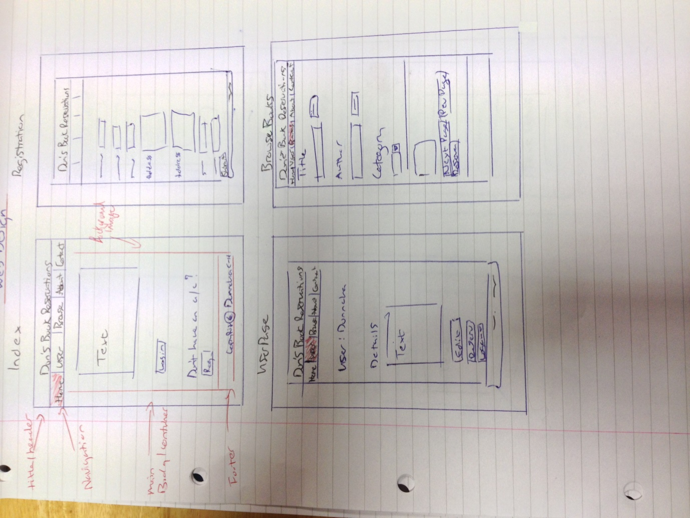

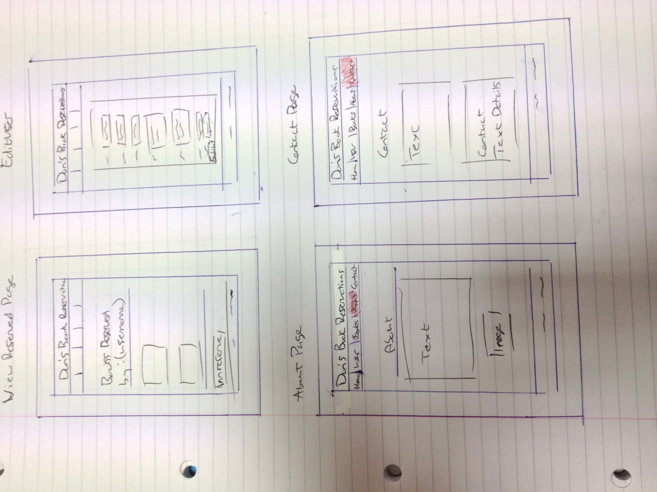

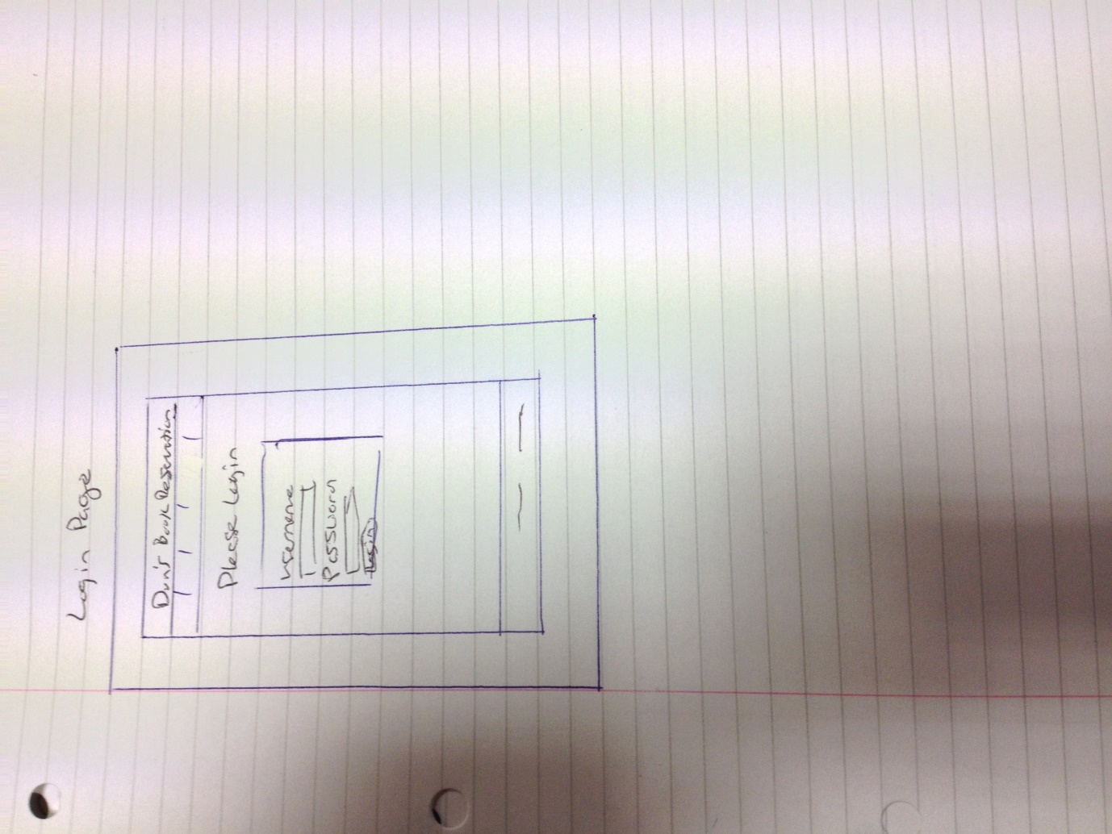

**Bibliography**

<http://static.guim.co.uk/sys-images/Arts/Arts_/Pictures/2007/12/14/books460.jpg> 26/11/ 14

<http://www.psdgraphics.com/file/old-telephone.jpg> 26/11/ 14

<http://www.hdpaperwall.com/wp-content/uploads/2013/10/website-backgrounds-hd-arena.jpg> 27/11/ 14

<https://idp.dit.ie/idp/Authn/images/logo.png> 27/11/ 14